**Relational Database Management System (1PGDMDSA04)**

**PGDM-trimester-1**

**RDBMS Final Trimester Project**

**(20 Marks)**

Project on

**Movie Recommendation using MySQL Relational Database**

**Implemented as a Part of the Subject:** Relational Database Management System

**Subject Code:** 1PGDMDSA04

**Implemented By:** Deep Prateek

**Roll Number:** PGDMDSA23-004

**Branch and Section Details:** Post Graduate Diploma in Management (Data Science & Analytics), 2023-25, Narayana Business School

**Instructed and Guided By:** Mr. Tushar Kakaiya

**Designation:** Professor of Practice

**Department:** Information Technology and Analytics

**Institute Name:** Narayana Business School



**Problem Statements for the Analysis:**

**NOTE: You should be writing SQL Scripts to achieve the solution to the below Problem Statements**

Statement

1. **Top ten most viewed movies with their movies Name (Ascending or Descending order)**

Code

with Most_Views_movies AS (

select m.MovieID, m.Title, COUNT(r.rating) as view_point

from movies as m

left join ratings as r on m.MovieID = r.MovieID

group by m.MovieID, m.Title)

select Title, view_point

from Most_Views_movies

order by view_point

desc limit 10;

Output

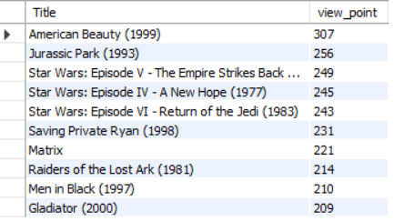

Statement

**2. Top twenty rated movies (Condition: The movie should be rated/viewed by at least 40 users)**

Code

with movie_top20_rating as (

Select m.movieid, count(r.userid) as no_of_users_rated, avg(r.rating) as avg_rating

from movies m join ratings r on m.movieid = r.movieid group by m.movieid having

no_of_users_rated > 40

)

select m.title, mc.no_of_users_rated, mc.avg_rating

from movie_top20_rating mc join movies m on m.movieid = mc.movieid order by mc.avg_rating desc limit 20;

Output

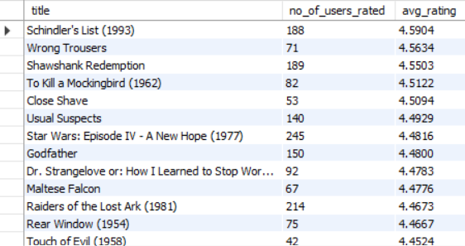

Statement

**3. We wish to know how have the genres ranked by Average Rating, for each profession and age**

**group. The age groups to be considered are: 18-35, 36-50 and 50+. You need to formulate results in following table:**

Code

with genre_Avg_rating as

(select m.genre,avg(r.rating) as Ratings,r.userid

from movies m

join ratings r

on m.movieid = r.movieid

group by m.genre,r.userid)

select u.age as '18-35',u.age as '36-50',u.age as '50 +',u.occupation,ge.genre,ge.ratings

from

users as u

join

genre_Avg_rating as ge

on u.userid = ge.userid

where '18-35' between 18 and 35 or

'36-50' between 36 and 50 or

'50+' between 51 and 150

order by age;

Output

